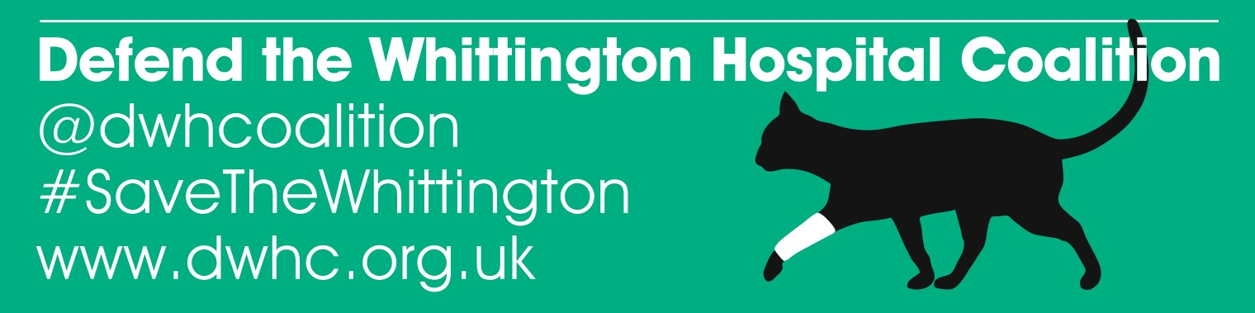

14 March 2013

Thousands expected on march to save Hospital

Thousands of patients, hospital staff and members of the public will march through the streets of north London on Saturday (16 March) to demonstrate their opostition to plans to sell off a third of the Whittington Hospital’s buildings, close 230 beds and cut 570 jobs, including 220 nursing posts.

The demonstration follows a successful 2010 campaign by local residents which overturned the government’s proposals to cut the Whittington’s Accident and Emergency, Paediatrics, Maternity and Intensive Care services.

The hospital is already operating over-capacity, with an average 94% bed occupancy rate (the Royal College of Surgeons and National Audit Office recommend that to minimise the risk of hospital acquired infections the maximum bed occupancy should not exceed 82%). This has led to patients being discharged early and creates a potentially dangerous situation in the event of a major terrorist attack, traffic accident or flu outbreak.

The cuts will privatise and move more services into the community as the hospital prepares for Foundation Trust status.

The Defend Whittington Hospital campaign is supported by dozens of local celebrities, including Annie Lennox, Domnic West, Christopher Biggins, Alexei Sayle, Alexandra Burke and Juliet Stevenson, local MPs and patient groups. Those speaking at the event include Owen Jones, journalist, political commentator and author of Chavs, Roger Lloyd Pack, Trigger from Only Fools and Horses, Natalie Bennett MP, leader of the Green Party, local MPs Frank Dobson, David Lemmy, Emily Thornberry and Jeremy Corbyn.

Shirley Franklin, chair of the Defend Whittington Hospital Coalition campaign said: “Sick people need to know they will be taken care of when they are at their most vulnerable. The hospital’s board argues people don’t want to be in hospital but privatised community care with underpaid staff with insufficient time to treat their patients is not the answer. This is symptomatic of the government’s cuts to our health services and must be fought.”

Notes

- The march will move off from Highbury Corner, at 11.30am on Saturday 16 March and make its way northbound up Holloway Road to the Whittingotn Hospital, Magdela Avenue, London N19.

- We will have two buses on the march, one at the front and one at the back, for people with mobility issues. The march will stop in Holloway Road, next to Whittington Park, to pick up people who want to join there and then at Archway Methodist Hall for others to join. Stewards will assist disabled people into the march. People need to get to these points by 11.30am as the buses won’t be running after that, and the Northern line at Archway will also be closed. We are also hoping to have a signer at the rally after the march
- For media enquiries please contact Shirley Franklin on 07958 745802.

- We urge everyone to sign the petition to stop the Whittington Hospital sell-off at dwhc.org.uk

